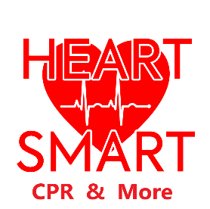 BLS for Healthcare Provider
CPR
Check for Responsiveness – Check for pulse/breathing 5-10 seconds – Gasps? Start CPR
Single rescuer – 30 Compressions – 2 Breaths Lower half of the sternum 100-120 per minute
Adult 2-2.4” at least 2” Child 1.5-2” Infant 1-1.5” 1/3 depth of chest
Allow for chest recoil, the heart refills with blood Switch compressors every 2 minutes
Two Rescuer – Adult 30 compressions 2 breaths – Pedi 15 compressions 2 breaths
Rescue Breathing – Adult 10 breaths per minute – Pedi 20-30 breaths per minute

AED
As soon as available turn it on and follow the prompts
Pads have to stick to the skin – remove hair – wipe any moisture from the chest only
AED looks for an abnormal cardiac rhythm, stop/restart to restore a normal rhythm

Team Dynamics
Roles/Tasks – Know your limitations, ask for a new task if out of your scope of practice
Clear messages – Closed loop communication repeat back task and completion
Constructive Intervention – Stop mistakes - Instruct correct CPR techniques

Choking
Adult & Child – Abdominal thrusts with in and up motion trying to dislodge to object
Infant – 5 back slaps then 5 chest trusts in a downward facing position for gravity
Unresponsive – 30 chest compressions – look in the airway for object and remove

